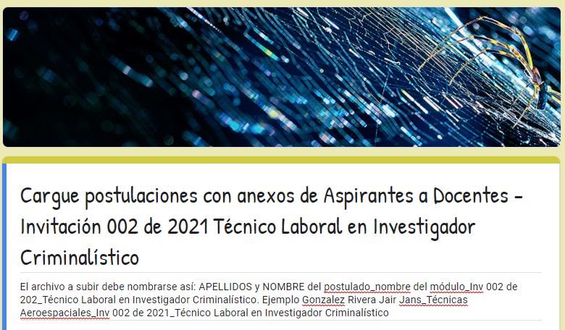

https://forms.gle/qm5BAF86Fxia6rDD7

