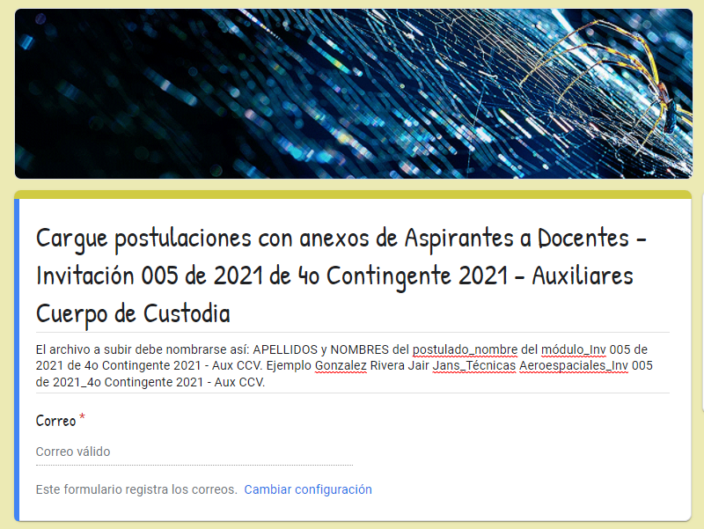

https://forms.gle/pZ24mrqrpSRCEQKz8

